STAC67

HW 2

Name:Zhengshuo Xu

Student number: 998300351

Date: November 3rd.

**Question 1.**

Pg 186 3.4

Pg 64 for original

(a)

> copier=read.table("copier.txt", header=F)

> colnames(copier)=c("y","x")

> copier

y x

1 20 2

2 60 4

3 46 3

4 41 2

5 12 1

6 137 10

7 68 5

8 89 5

9 4 1

10 32 2

11 144 9

12 156 10

13 93 6

14 36 3

15 72 4

16 100 8

17 105 7

18 131 8

19 127 10

20 57 4

21 66 5

22 101 7

23 109 7

24 74 5

25 134 9

26 112 7

27 18 2

28 73 5

29 111 7

30 96 6

31 123 8

32 90 5

33 20 2

34 28 2

35 3 1

36 57 4

37 86 5

38 132 9

39 112 7

40 27 1

41 131 9

42 34 2

43 27 2

44 61 4

45 77 5

attach(copier)

dotchart(x, xlab="number of copiers serviced")

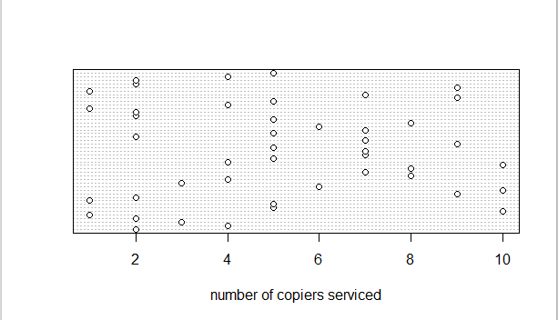

We can see from the plot that x spreads from 1 to 10, and the distribution seems normal. There is no outlying case with respect to this variable.

(b)

> plot(x, xlab="time", ylab="number of copiers serviced")

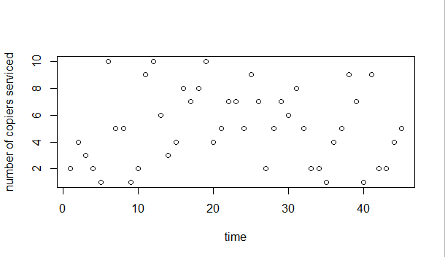

The plot shows that there is no correlation between time and the number of copiers serviced.

(c)

> xbar=mean(x)

> ybar=mean(y)

> ssx=sum((x-xbar)^2)

> spxy=sum((y-ybar)*(x-xbar))

> b1=spxy/ssx

> b1

[1] 15.03525

> b0=ybar-b1*xbar

> b0

[1] -0.5801567

> yhat=b0+b1*x

> residual=y-yhat

> stem(residual)

The decimal point is 1 digit(s) to the right of the |

-2 | 30

-1 |

-1 | 3110

-0 | 99997

-0 | 44333222111

0 | 001123334

0 | 5666779

1 | 112234

1 | 5

We see that the residuals range from -23 to 15; there are two outliers -20 and -30 if we take those out the residuals range from -13 to 15.

(d)

> plot(yhat,residual)

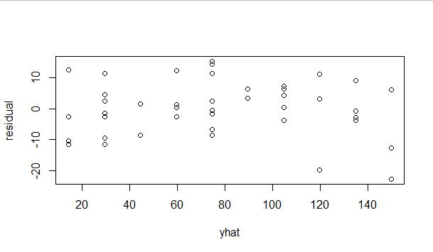

> plot(x,residual)

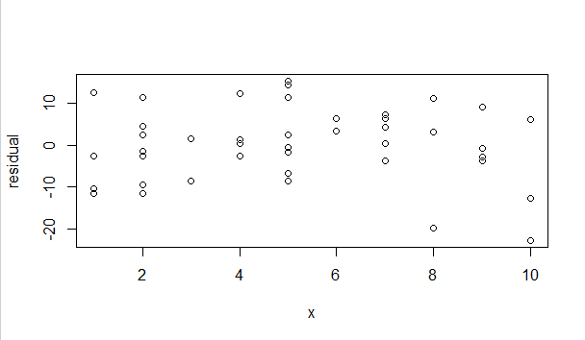

Therefore the plots provide the same information. From these plots we can see that the regression

Function is linear and the error variance is constant.

(e)

> rankofres=rank(residual)

> n=length(y)

> SSE=sum(residual^2)

> MSE=SSE/(n-2)

> zscore=qnorm((rankofres-0.375)/(n+0.25))

> expres=zscore*sqrt(MSE)

> plot(expres,residual,xlab="expected values",ylab="residuals")

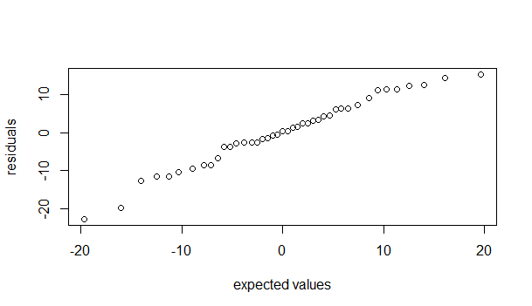

> Sxy=sum((expres-mean(expres))*(residual-mean(residual)))

> Sxx=sum((expres-mean(expres))^2)

> Syy=sum((residual-mean(residual))^2)

> r=Sxy/sqrt(Sxx*Syy)

> r

[1] 0.9892079

Therefore the coefficient of correlation is 0.9892079. From table B.6, we see that the critical value is between 0.977 and 0.981 when n=45 which is smaller than the coefficient of correlation; therefore assumption of normality is reasonable.

(f)

> plot(residual,ylab="residuals")

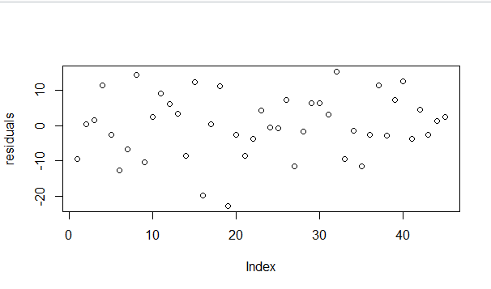

Therefore the error terms are not correlated over time.

(g)

Null hypothesis - H0: error variance is constant.

Alternative hypothesis - Ha: error variances is not constant.

Decision rule: if X^2(BP)>X^2(0.95, 1)=3.841 we reject the null hypothesis;

If X^2(BP)<3.841 we accept the null hypothesis.

> plot(residual,ylab="residuals")

> e2=residual^2

> spe2x=sum((e2-mean(e2))*(x-mean(x)))

> ssx=sum((x-mean(x))^2)

> b1e2=spe2x/ssx

> SSE=sum(e2)

> SSRsr=b1e2^2*ssx

> chi2BP=(SSRsr/2)/((SSE/n)^2)

> chi2BP

[1] 1.31468

Conclusion:

X^2(BP)=1.31468<3.841.

Therefore we accept the null hypothesis that error variance is constant.

(h)

> copier1=read.table("copier1.txt",header=F)

> attach(copier1)

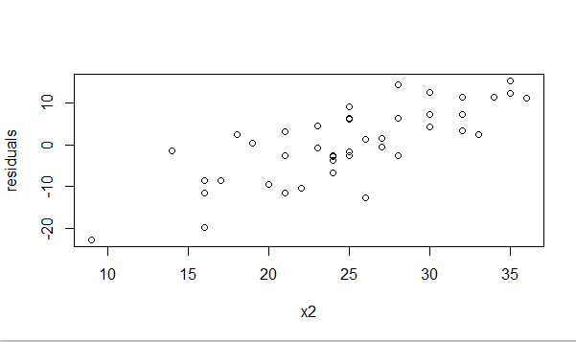

> plot(V4,residual,xlab="x3",ylab="residuals")

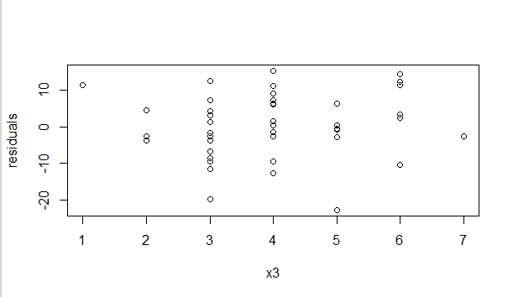

From the plot of x2 we see that there is a positive linear correlation between x2 and residuals but we see no correlation from the second plot. Therefore the model can be included by including x2

**Q2.**

> electr=read.table("electr.txt",header=F)

> electr

V1 V2

1 2 3.2

2 3 2.9

3 4 -1.7

4 5 -2.0

5 6 -2.3

6 7 -1.2

7 8 -0.9

8 9 0.8

9 10 0.7

10 11 0.5

> attach(electr)

> plot(V1,V2,xlab="x",ylab="residuals")

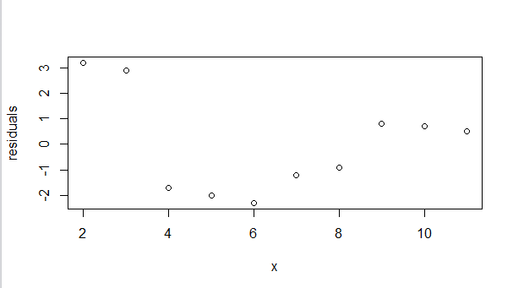

The problem is that there is a pattern for the distribution of the residuals here therefore error variance is not constant; and yes a transformation might alleviate the problem

**Q3.**

(a)

> drug=read.table("drug.txt",header=F)

> drug

V1 V2

1 -1 0.5

2 0 2.1

3 1 -3.4

4 -1 0.3

5 0 -1.7

6 1 4.2

7 -1 -0.6

8 0 2.6

9 1 -4.0

> attach(drug)

> plot(V1,V2,xlab="x",ylab="residuals")

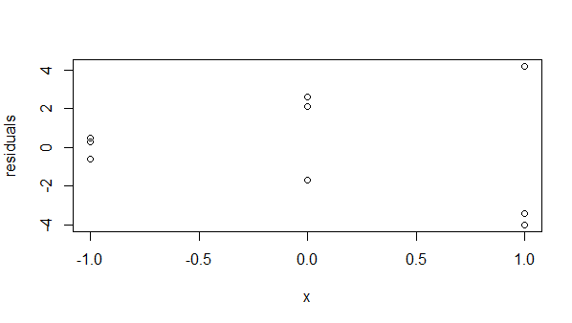

From the plot we see that x gets larger when the residuals get larger and when the residuals get smaller; therefore we conclude that error variance is not constant.

(b)

Null hypothesis - H0: error variance is constant.

Alternative hypothesis - Ha: error variances is not constant.

Decision rule: if X^2(BP)>X^2(0.95, 1)=3.841 we reject the null hypothesis;

If X^2(BP)<3.841 we accept the null hypothesis.

> x=V1

> e=V2

> e2=e^2

> spe2x=sum((e2-mean(e2))*(x-mean(x)))

> ssx=sum((x-mean(x))^2)

> b1e2=spe2x/ssx

> SSE=sum(e2)

> SSRsr=b1e2^2*ssx

> chi2BP=(SSRsr/2)/(SSE/length(e))^2

> chi2BP

[1] 3.717924

Since 3.717924<3.841, we accept the null hypothesis; this does not support my preliminary findings in part (a).

**Q4.**

4.3 (a)

> copier=read.table("copier.txt", header=F)

> colnames(copier)=c("y","x")

> attach(copier)

[1] 5.111111

From the handwritten sheet attached we see the b0 and b1 tend to err in opposite directions.

(b)

CI for :



> SSE=sum(resi^2)

> n=length(x)

> MSE=SSE/(n-2)

> s2b0=MSE*((1/n)+xbar^2/sum((x-xbar)^2))

> sb0=sqrt(s2b0)

> t=qt((1-0.05/4), n-2)

> CI0=c(b0-t*sb0, b0+t*sb0)

> CI0

[1] -7.092642 5.932329

CI for :



> s2b1=MSE/sum((x-xbar)^2)

> sb1=sqrt(s2b1)

> CI1=c(b1-t*sb1, b1+t*sb1)

> CI1

[1] 13.91322 16.15728

(c) yes , since 0 lies within CI of b0 and 14 lies within CI of b1.

4.7

(b)

Scheffe:

> SP2=2*qf(1-0.1,2,n-2)

> SP=sqrt(SP2)

> SP

[1] 2.204725

Bonferroni:

> BP=qt(1-0.1/(2*2),n-2)

> BP

[1] 2.016692

SP>BP, therefore Scheffe Procedure will provide tighter prediction limits.

(c)

4 copiers:

> yhat1=b0+b1*4

> s2pred=(1+1/n+(4-xbar)^2/sum((x-xbar)^2))*MSE

> spred=sqrt(s2pred)

> CIy1=c(yhat1-BP*spred,yhat1+BP*spred)

> CIy1

[1] 41.35419 77.76748

Therefore the 90% CI for 4 copiers is (41.35419, 77.76748).

7 copiers:

> yhat2=b0+b1*7

> s2pred2=(1+1/n+(7-xbar)^2/sum((x-xbar)^2))*MSE

> spred2=sqrt(s2pred2)

> CIy2=c(yhat2-BP*spred2,yhat2+BP*spred2)

> CIy2

[1] 86.39922 122.93394

Therefore the 90% CI for 7 copiers is (86.39922, 122.93394).

**Q5.**

(a)

> typo=read.table("typo.txt",header=F)

> attach(typo)

> x=V1

> y=V2

> spxy=sum(x*y)

> sxx=sum(x^2)

> b1=spxy/sxx

> b1

[1] 18.0283

Therefore, the estimated regression function is: Y=18.0283X.

(b)

> plot(x,y,xlab="number of galleys for a manuscript",ylab="total cost")

> abline(a=0,b=b1)

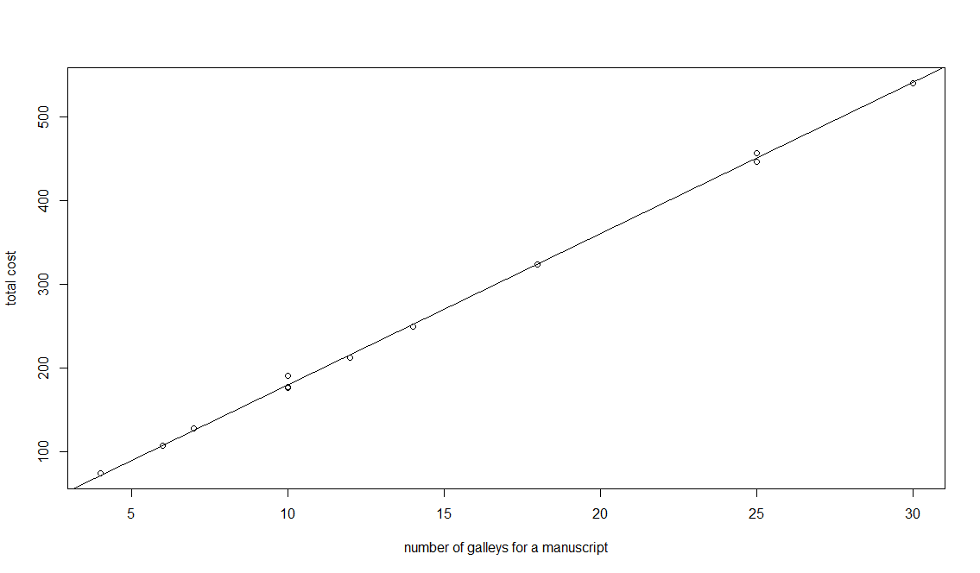

Since all the dots are really close to the line we conclude that the linear regression function through the origin appears to provide a good fit here.

(c)

Null hypothesis - H0: =18.0283 (obtained from part a)



Alternative hypothesis - Ha: not equal to 18.0283.



Decision rule: if t<-t(0.99, 1) or t>t(0.99,1) we reject the null hypothesis;

If -t(0.99, 1)<t<t(0.99, 1), we accept the null hypothesis.

where by checking the table we see t(0.99, 1)=2.718; (df=12-1=11)

> n=12

> yhat=b1*x

> residual=y-yhat

> SSE=sum(residual^2)

> MSE=SSE/(n-1)

> s2b1=MSE/sum(x^2)

> sb1=sqrt(s2b1)

> t=(17.5-18.0283)/sb1

> t

[1] -6.646642

-6.646642<-2.718

t<-t(0.99,1) therefore we reject the null hypothesis. This standard should be revised.

(d)

> ts=2.718

> y1=b1*10

> s2pred=(1+10^2/sum(x^2))*MSE

> spred=sqrt(s2pred)

> CIy1=c(y1-ts*spred,y1+ts*spred)

> CIy1

[1] 167.8445 192.7216

Therefore the 98% prediction interval is (167.8445, 192.7216).

**Q6.**

5.4

YTY:

> flavor=read.table("flavor.txt", header=F)

> attach(flavor)

> n=length(x)

> X=V1

> Y=V2

> > UnitVec <- rep(1, n)

> X <- cbind(UnitVec, x)

> colnames(X) <- c("1", "x")

> Y <- matrix(y, ncol = 1)

> YY <- t(Y) %*% Y

> YY

[,1]

[1,] 503.77

XTX:

> XX <- t(X) %*% X

> XX

1 x

1 5 0

x 0 160

XTY:

> XY <- t(X) %*% Y

> XY

[,1]

1 49.7

x -39.2

5.12

(XTX)^(-1):

> XXINV=solve(XX)

> XXINV

1 x

1 0.2 0.00000

x 0.0 0.00625

5.23

(a)

Vector of estimated regression coefficients:

> b <- solve(XX) %*% XY

> b

[,1]

1 9.940

x -0.245

Vector of residuals:

> e <- Y - yhat

> e

[,1]

[1,] -0.18

[2,] 0.04

[3,] 0.26

[4,] 0.08

[5,] -0.20

SSR:

> J <- matrix(1, nrow = n, ncol = n)

> SSR <- t(b) %*% t(X) %*% Y - (t(Y) %*% J %*% Y)/n

> SSR

[,1]

[1,] 9.604

SSE:

> SSE <- t(Y) %*% Y - t(b) %*% t(X) %*% Y

> SSE

[,1]

[1,] 0.148

Estimated variance-covariance:

> MSE <- sum(e^2)/3

> s2b <- MSE * solve(t(X) %*% X)

> s2b

1 x

1 0.009866667 0.0000000000

x 0.000000000 0.0003083333

Point estimate of E(Yh) when Xh=-6:

> Xh <- -6

> Xh <- cbind(1,Xh)

> Yhhat <- Xh%*%b

> Yhhat

[,1]

[1,] 11.41

Estimated variance of Yhath when Xh=-6:

> s2Yhhat <- MSE*Xh%*%solve(t(X)%*%X)%*%t(Xh)

> s2Yhhat

[,1]

[1,] 0.02096667

(b)

We see that the values are symmetric; their mean is 0.

(c)

> H <- X %*% solve(t(X) %*% X) %*% t(X)

> H

[,1] [,2] [,3] [,4] [,5]

[1,] 0.6 0.4 0.2 0.0 -0.2

[2,] 0.4 0.3 0.2 0.1 0.0

[3,] 0.2 0.2 0.2 0.2 0.2

[4,] 0.0 0.1 0.2 0.3 0.4

[5,] -0.2 0.0 0.2 0.4 0.6

(d)

> I <- matrix(0, nrow = 5, ncol = 5)

> diag(I) <- 1

> s2e <- (I - H) * MSE

> s2e

[,1] [,2] [,3] [,4] [,5]

[1,] 0.019733333 -0.019733333 -0.009866667 0.000000000 0.009866667

[2,] -0.019733333 0.034533333 -0.009866667 -0.004933333 0.000000000

[3,] -0.009866667 -0.009866667 0.039466667 -0.009866667 -0.009866667

[4,] 0.000000000 -0.004933333 -0.009866667 0.034533333 -0.019733333

[5,] 0.009866667 0.000000000 -0.009866667 -0.019733333 0.019733333

**7.**

6.5

(a)

> brand=read.table("brand.txt",header=F)

> colnames(brand)=c("y","x1","x2")

> pairs(brand)

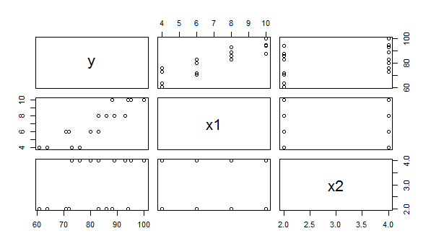

> cor(brand)

y x1 x2

y 1.0000000 0.8923929 0.3945807

x1 0.8923929 1.0000000 0.0000000

x2 0.3945807 0.0000000 1.0000000

Based on these we can tell that there is a strong positive correlation between x1 and y, and a strong positive relation between y and x2. However there is no correlation between x1 and x2.

(b)

> attach(brand)

> n <- length(x1)

> UnitVec <- rep(1, n)

> x <- cbind(UnitVec, x1, x2)

> XX <- t(x) %*% X

> XY <- t(x) %*% y

> XXINV=solve(xx)

> b=XXINV%*%XY

> b

[,1]

37.650

x1 4.425

x2 4.375

The estimated regression function is y=37.650+4.425x1+4.375x2; b1 is interpreted as :a unit of increase in moisture content (x1) will cause the degree of brand liking (y) to increase by 4.425 units if x2 does not change.

(c)

Residuals:

> yhat <- x%*%b

> e <- y-yhat

> e

[,1]

[1,] -0.10

[2,] 0.15

[3,] -3.10

[4,] 3.15

[5,] -0.95

[6,] -1.70

[7,] -1.95

[8,] 1.30

[9,] 1.20

[10,] -1.55

[11,] 4.20

[12,] 2.45

[13,] -2.65

[14,] -4.40

[15,] 3.35

[16,] 0.60

Box plot of the residuals:

> boxplot(e)

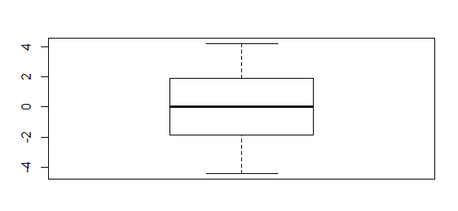

We can see from the box plot that it is symmetric hence the residuals are evenly distributed; the residuals also has a median of 0.

(d)

Yhat:

> plot(e~yhat)

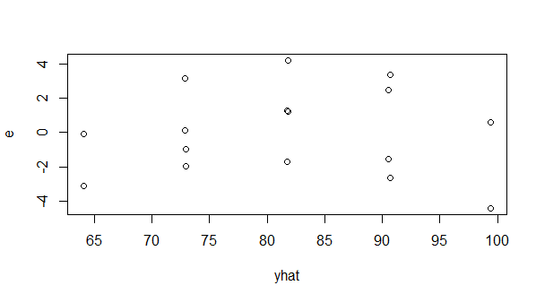

The residuals seem to be randomly distributed therefore error variance is constant.

x1:

> plot(e~x1)

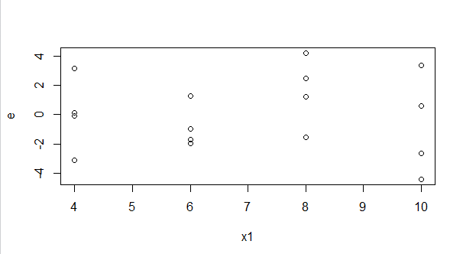

The residuals seem to be randomly distributed therefore error variance is constant.

x2:

> plot(e~x2)

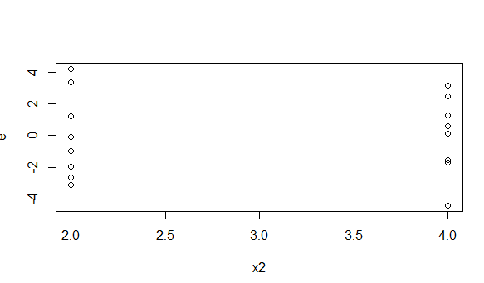

The residuals are distributed at extreme values of x2 but no exact pattern therefore error variance is constant.

x1x2:

> x1x2=x1*x2

> plot(e~x1x2)

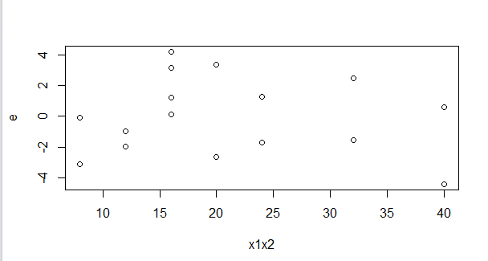

The residuals seem to be randomly distributed.

Normal probability plot:

> qqnorm(e)

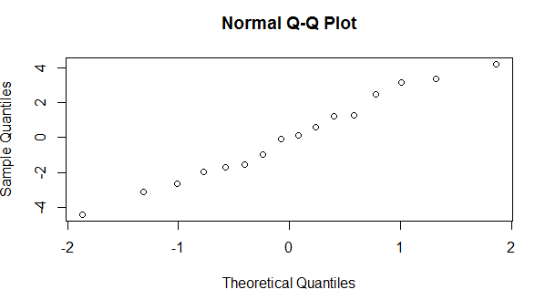

The dots seem to be close to a line therefore the residuals are normally distributed.

(e)

Null hypothesis - H0: error variance is constant.

Alternative hypothesis - Ha: error variances is not constant.

Decision rule: if X^2(BP)>X^2(0.99, 2)=9.210 we reject the null hypothesis;

If X^2(BP)<9.210 we accept the null hypothesis.

(f)

Null hypothesis - H0: E(x)= 0+1X1+2X2



Alternative hypothesis - Ha: E(x) not equal to



Decision rule: if F>F(0.99, c-p, n-c)=6.632 we reject the null hypothesis;

If F<6.632 we accept the null hypothesis.

|  |  |  |  |  |  |  |  |  |
| --- | --- | --- | --- | --- | --- | --- | --- | --- |
|  | j = 1 | j = 2 | j = 3 | j = 4 | j = 5 | j = 6 | j = 7 | j = 8 |
| Replicate | X1= 4  X1= 2 | X1= 4  X1= 4 | X1= 6  X2 = 2 | X1= 6  X2 = 4 | X1= 8  X2= 2 | X1= 8  X2= 4 | X1= 10  X2 = 2 | X1= 10  X2 = 4 |
| i = 1 | 64 | 73 | 72 | 80 | 83 | 89 | 88 | 95 |
| i = 2 | 61 | 76 | 71 | 83 | 86 | 93 | 94 | 100 |
| Mean | 62.5 | 74.5 | 71.5 | 81.5 | 84.5 | 91 | 91 | 97.5 |

(obtained using method from textbook example)

SSPE=(64 - 62.5)^2 + (61 - 62.5)^2 + … (95 - 97.5)^2+ (100 - 97.5)^2= 57

V

> SSPE=57

> SSE=t(y) %*% y - t(b) %*% t(x) %*% y

> SSE

[,1]

[1,] 94.3

> F = ((SSE - SSPE)/(8 - 3))/(SSPE/(16 - 8))

> F

[,1]

[1,] 1.047018

F=1.047018<6.632

Therefore we reject the null hypothesis hence E(x)= 0+1X1+2X2.



6.6

(a)

Null hypothesis - H0: 1=2=0



Alternative hypothesis - Ha: one of 1 and 2 is not equal to 0.



Decision rule: if F>F(0.99, n-3)=6.701 we reject the null hypothesis;

If F<6.701 we accept the null hypothesis.

> p=3

> MSE=sum(e^2)/(n-p)

> J=matrix(1, nrow = n, ncol = n)

> SST=t(y) %*% y - (t(y) %*% J %*% y)/n

> SSR=t(b) %*% t(x) %*% y - (t(y) %*% J %*% y)/n

> MSR=SSR/(p-1)

> F1=MSR/MSE

> F1

[,1]

[1,] 129.0832

F=1.290832>6.701 hence we reject the null hypothesis. Therefore one of 1 and 2 is not equal to 0.



(b)

> pv=1-pf(f,2,n-2-1)

> pv

[,1]

[1,] 2.658261e-09

(c)

> p=dim(x)[[2]]

> B=qt(1-0.01/(2*2), n-p)

> s2b=MSE * solve(t(x) %*% x)

> s2b

UnitVec x1 x2

UnitVec 8.9766346 -6.347115e-01 -1.3600962

x1 -0.6347115 9.067308e-02 0.0000000

x2 -1.3600962 1.887513e-16 0.4533654

> sb=sqrt(diag(s2b))

> sb

UnitVec x1 x2

2.9961032 0.3011197 0.6733241

for1



> CIb1=c(4.425 - B * 0.3011197, 4.425 + B * 0.3011197)

> CIb1

[1] 3.409483 5.440517

Therefore there is 99% probability that 1 will fall between 3.409483 and 5.440517



For 2:



> CIb2=c(4.375 - B * 0.6733241, 4.375 + B * 0.6733241)

> CIb2

[1] 2.104236 6.645764

Therefore there is 99% probability that 2 will fall between 2.104236 and 6.645764.



6.7

(a)

> R2=SSR/SST

> R2

[,1]

[1,] 0.952059

Therefore 95.2059% of the variation in response variable is explained by the association between them.

(b)

> r=cor(y,yhat)

> R21=r^2

> R21

[,1]

[1,] 0.952059

Yes, it is equal to the coefficient of multiple determination in part (a)

6.8

(a)

> xh=cbind(1,x1=5,x2=4)

> yhat=xh%*%b

> t=qt(1-0.01/2,n-p)

> s2yhat=MSE*xh%*%solve(t(x)%*%x)%*%t(xh)

> syhat=sqrt(s2yhat)

> CIyhat=c(yhat-t*syhat, yhat+t*syhat)

> CIyhat

[1] 73.88111 80.66889

Hence there is 99% probability that E(Yh) will be in the interval from 73.88111 to 80.66889.

(b)

> s2pred=MSE+s2yhat

> spred=sqrt(s2pred)

> CIpr=c(yhat-t*spred, yhat+t*spred)

> CIpr

[1] 68.48077 86.06923